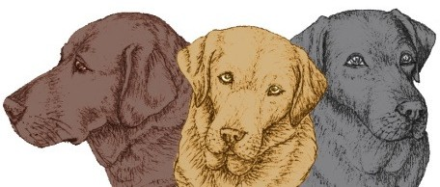

LABRADOR WELFARE
Office: 90 Leader Road, Sheffield S6 4GH E: enquiries@labradorwelfare.org
Registered Charity Number 1012192

GDPR UPDATE & CONSENT FORM

Your privacy is important to us and we want to make sure we’re communicating with our members and supporters in a way that has their consent, and which is in line with UK law on data protection.

In order to do this, we need your consent as to how we may contact you and would be grateful if you’d complete and return this form so we can ensure we have the correct details that you’d like us to use to contact you and you can let us know what you’d like to hear from us about.

YOUR PERSONAL DETAILS

YOUR NAME(S):

YOUR ADDRESS:

YOUR POST CODE:

E-mail address: Contact Tel No (inc code)

By signing this form, you are confirming that you are consenting to Labrador Welfare holding and processing your personal data for the following purposes (please tick the boxes where you grant consent):

☐ To provide you with the service or information you require (including rehoming, adopting,
membership, general information about the work of the charity

☐ To send you newsletters and updates on the work of the charity
☐ To inform you of fundraising activities and campaigns Labrador Welfare are involved in

☐ To acknowledge donations and gifts

I allow Labrador Welfare to contact me by: | EMAIL | PHONE | POST

You can grant consent to all the purposes; one of the purposes or none of the purposes. Where you do not grant consent, we will not be able to use your personal data; (so for example we may not be able to let you know about forthcoming events); except in certain limited situations, such as where required to do so by law or to protect members of the public from serious harm. You can find out more about how we use your data from our Privacy Policy which is available on our web site or by request.
You can withdraw or change your consent at any time by contacting the Secretary at the postal address shown at the top of this form or email to enquiries@labradorwelfare.org. Please note that all processing of your personal data will cease once you have withdrawn consent, other than where this is required by law, but this will not affect any personal data that has already been processed prior to this point.
Please sign and return this form to us at the address above or e-mail it to us at enquiries@labradorwelfare.org

Signed:

Date:
Chairman: Mr RW Carnall Secretary: Mrs R Leckie Treasurer: Ms D Ellis
Rehoming Co-ordinator: Mrs R Leckie
Trustees: Mr RW Carnall, Ms D Ellis, Mrs R Leckie, Miss S Roberts, Mrs N Aldgate

